STA2023 – Statistical Methods I
Instructor: Dr. Emil Agbemade
Chapter 3: Numerically Summarizing Data
Table of Contents
3.1: Measures of Central Tendency 2
Mean 2
Median 3
Resistance 4
Relation between the Mean, Median, and Distribution Shape 6
Mode 7
3.2 Measures of Dispersion 8
Range 9
Standard Deviation 10
Describing Bell-Shaped Data 13
3.4 Measures of Position and Outliers 17
Z-scores 17
Percentiles 18
Quartiles and Outliers 19
Outliers 21
3.5 The Five-Number Summary and Boxplots 22
Using a Boxplot to Describe the Shape of a Distribution 26

Learning Objectives: By the end this chapter, students should be able to:
- Calculate and interpret measures of center (mean, median, and mode)
- Calculate and interpret measures of spread (range and standard deviation)
- Describe measures of position (percentiles, z-scores, and quantiles)
- Use the Empirical Rule and Chebyshev’s Inequality to describe datasets.
- Calculate five-number summaries and use them to construct boxplots.

3.1: Measures of Central Tendency
- In chapter 2, we looked at graphical ways to describe data.
- Now, we will use numbers to describe data. We often use the “average” to describe a typical value, such as in the examples below:
  - The average miles per gallon of gasoline of the 2023 Chevrolet Corvette Z07 in highway driving is 21.
  - According to the U.S. Census Bureau, the national average commute time to work in 2019 was 27.6 minutes.
  - According to the U.S. Census Bureau, the average household income in 2022 was $78,813.
- In 3.1, we will look at the three most widely used measures of central tendency:
  - Mean
  - Median
  - Mode

Mean
- The is usually what people think of when people say the word “average”.
- While other means do exist, we will solely focus on the arithmetic mean.

Definition: The arithmetic mean of a variable is computed by adding all the values in the dataset and dividing by the number of observations.

The population mean

The sample mean

Example 1: Computing a Population Mean and a Sample Mean
The following represents scores of all 7 students on the first exam of a small statistics course:
76 | 80 | 84 | 86 | 90 | 92 | 94

Part (a): Compute the population mean of this data.

Part (b): Suppose a simple random sample of n = 3 employees was taken. If the 1st, 3rd, and 6th students were chosen, calculate the sample mean. Repeat this, but suppose the 2nd, 3rd, and 7th students were chosen.

Median
Definition: The median

Steps in Finding the Median of a Data Set

Step 1:

Step 2:

Step 3:
- If n is odd:

- If n is even:

Example 2: Determining the Median of a Data Set
The following represents scores of 7 students on the first exam:
76 | 80 | 84 | 86 | 90 | 92 | 94

Part (a): Calculate the median exam score.

Part (b): Suppose an 8th student was in the course but dropped it. The following data includes the 8th student’s first exam score:
32 | 76 | 80 | 84 | 86 | 90 | 92 | 94

Resistance
- Depending on the dataset, sometimes the mean is better and sometimes the median is better to describe datasets.
- One main difference between them is the resistance of the numerical summary.
Definition: A numerical summary of data is said to be resistant if

The median is resistant, while the mean is not resistant. We will demonstrate this with an example.

Example 3: Work Travel Times
The following data represent the travel times (in minutes) to work for all seven employees of a start-up web development company.
5, 18, 23, 23, 26, 36, 43
- Compute the population mean of this data.

- Compute the median of this data.

- Suppose the start-up company hires a new employee. The travel time of the new employee is 70 minutes. Determine the mean and median of the “new” data set.
5, 18, 23, 23, 26, 36, 43, 70

- Compare the results from parts (a) – (c). How does the mean and median of travel times change with the new employee? Which numerical summary is more resistant?

Relation between the Mean, Median, and Distribution Shape
- When we describe a distribution (such as a histogram), we want to describe three things:
  - Shape (chapter 2)
  - Center (chapter 3.1)
  - Spread (chapter 3.2)
- Knowing the shape of the histogram will determine how the mean and median compare to one another:

Distribution Shape
Skewed Left
Symmetric
Skewed right

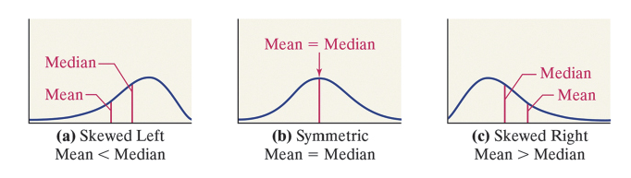
Example 4: For each situation, determine if the distribution of data will be skewed left, symmetric, or skewed right.
- Exam scores have a mean of 65 points (out of 100) and a median of 75 points.
- In a small town, the mean house sales price is $172,950 and the median house price is $173,000.
- In a class, the mean SAT score is 1300 (out of 1600) and a median of 1150 points.
- The heights of men in the US have a mean of 69 inches and a median of 69 inches.

A word of caution is in order. The relation between the mean, median, and skewness are guidelines only. The guidelines tend to hold up well for continuous data, but when the data is discrete, the rules can be easily violated.

Mode
Definition: The mode

To compute the mode, tally the number of observations that occur for each data value. The data value that occurs most often is the mode. A set of data can have no mode, one mode, or more than one mode.
- If only one value occurs most, it is the mode.
- If multiple values occur most, they are all the mode.
- If no observation occurs more than once, we say the data have no mode.

Example 5: Work Travel Times
- The following data represent the travel times (in minutes) to work for all seven employees of a start-up web development company. Find the mode.
5, 18, 23, 23, 26, 36, 43

- For two other company, the travel times (in minutes) were also recorded. Determine the mode for each company.

Company A: 7, 12, 12, 20, 20, 25

Company B: 5, 10, 15, 20, 27, 44

3.2 Measures of Dispersion
- In Section 3.1, we discussed measures of central tendency. These measures describe the typical value of a variable. We would also like to know the amount of dispersion in the variable.
Definition: Dispersion

- The example below shows why measures of central tendency alone are not sufficient in describing a distribution.

Example 6: Comparing Two Sets of Data
The data in Table 7 represent the IQ scores of a random sample of 100 students from two different universities. For each university, compute the mean IQ score and draw a histogram using a lower class limit of 55 for the first class and a class width of 15. Comment on the results.
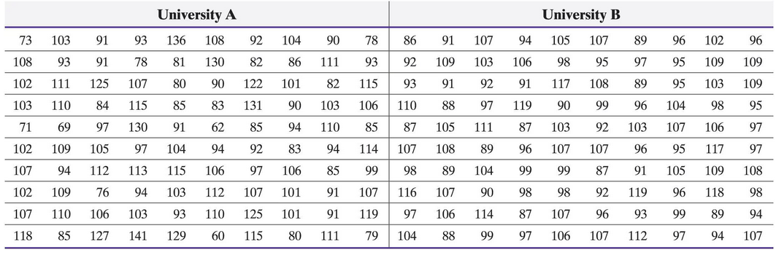

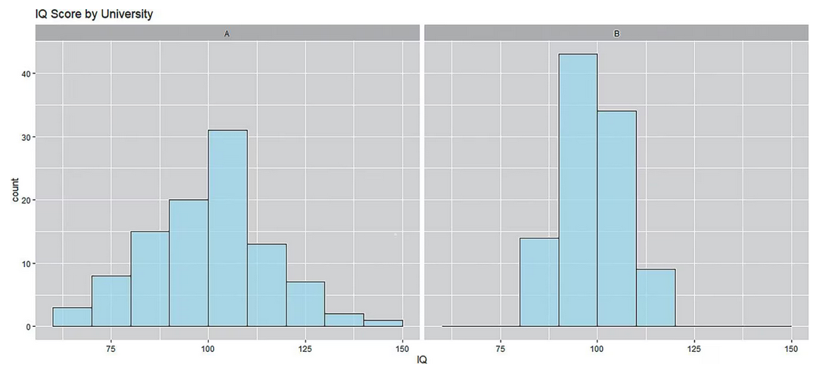
- Describing the shape:
- Describing the center:
- Describing the spread (dispersion):

Range
Definition: The range, R, of a variable is

EXAMPLE: The following data represents the travel times (in minutes) to work for all seven employees of a start-up web development company. Find the range.
5, 18, 23, 23, 26, 36, 43

- Pro of using range: easy to calculate and understand.
- Con of using range: not resistant and very prone to extreme values

Standard Deviation
- Measures of dispersion are meant to describe how spread out data is.
- In other words, they describe how far, on average, each observation is from a typical data value.
- Standard deviation is based on the deviation about the mean.
- For a population, the deviation about the mean for the “ith” observation is:

- For a sample, the deviation about the mean for the “ith” observation is:

- The sum of all deviations about the mean is equal to 0. That is,

- However, if we want to “average” deviation, we need to take the negative deviations out of the picture and just measure the absolute distance.
  - We could use absolute value, but if you’ve taken calculus before, you know how much of a pain absolute values can be with their properties.
  - Instead, we square the variations. These squared variations don’t have an intuitive interpretation, so we “undo” the squaring process by taking the square root of the sum of squared deviations
Definition: Population Standard Deviation

Example 7: Compute the population standard deviation of the test scores below. Note that the mean of the dataset is 79.

Score | Population Mean | Deviation about the Mean | Squared Deviations
82 | 79
77 | 79
90 | 79
70 | 79
62 | 79
68 | 79
74 | 79
84 | 79
94 | 79
88 | 79

Unlike the population mean vs. sample mean which have extremely different formulas, the population standard deviation vs. population standard deviation have a distinct difference between them.

We will use Excel for making standard deviation calculations much easier.

Definition: The sample standard deviation, s, of a variable is

Example 8: Suppose a sample of four students were taken from the class above. Find the sample standard deviation.
Score | Sample Mean | Deviation About the Mean | Squared Deviations
62 | 73.75
88 | 73.75
77 | 73.75
68 | 73.75

- We can use standard deviation to determine if a value is “near” a typical value or if it is “far away.”
- For example, if we are comparing two measurements, is 31 cm far from a mean of 25cm?
  - If the standard deviation is 6 cm:

  - If the standard deviation is 0.5 cm:

Describing Bell-Shaped Data
- If a variable has a bell-shaped distribution, there we can use the mean and standard deviation to describe where most of the data is located at.
- We call the rule describing this the Empirical Rule:

Definition: If a distribution is roughly bell-shaped, then:
- Approximately _______ of the data will lie within 1 standard deviation of the mean.
- Approximately _______ of the data will lie within 2 standard deviations of the mean.
- Approximately _______ of the data will lie within 3 standard deviations of the mean.

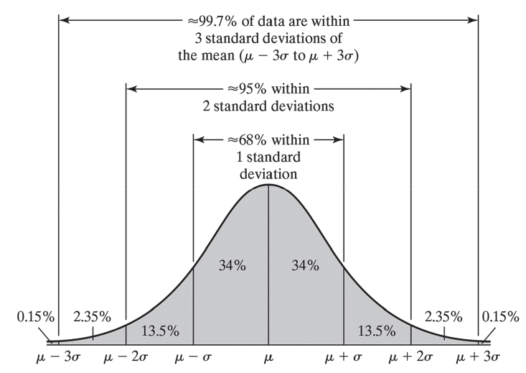

Example 9: The waist circumference of 2-year-old males is bell-shaped with mean 48.5 cm and standard deviation 4.8 cm.
- About 95% of 2-year-old males will have waist circumferences between what values?

- What percentage of 2-year-old males have waist circumference between 34.1 cm and 62.9 cm?

- What percentage of 2-year-old males have waist circumference between 53.3 cm and 62.9 cm?



- What happens if a variable is not bell-shaped? We do have a rule to guarantee the minimum number of observations within certain bounds.
[Not Tested] Definition: Chebyshev’s Inequality: For any data set or distribution,

Example 10: Recall the example about the graduation rate of various universities in the US. The mean graduation rate was 65 with a standard deviation of 17. A histogram is shown below:
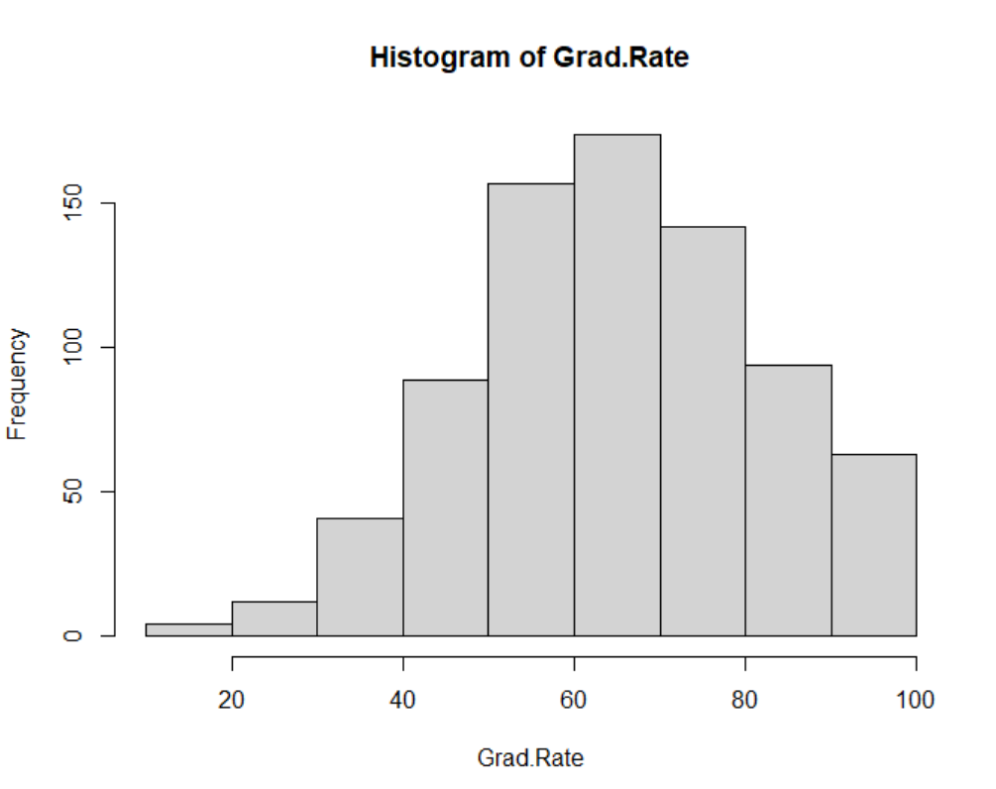
- Which rule should be used to describe the dataset: the Empirical Rule or Chebyshev’s Inequality?

- Using the rule in part (a) to describe the percentage of universities with a graduation rate between 31% and 99%.

3.4 Measures of Position and Outliers
- If we have a specific observation that we want to describe in a dataset, how do we describe the position of that dataset relative to all other values? We have a few tools, including:
  - Z-scores
  - Percentiles
  - Quartiles

Z-scores
Definition: The z-score

- Most observations are between -2 and +2.
Example 11: The mean ACT score is 18 with a standard deviation of 6. The mean SAT score is 1000 with a standard deviation of 200. Student A took the ACT and scored a 27. Student B took the SAT and scored 1200. Who had a relatively higher score?

Percentiles
Definition: The kth percentile, denoted P_{k}, of a set of data is

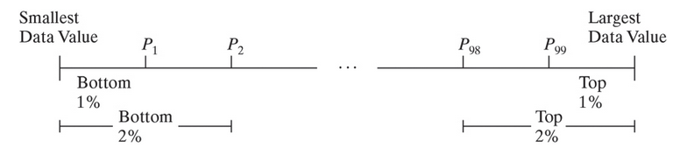

Example 12: For a certain scholarship, students can get a full scholarship if they are in the 95th percentile of all test takers. Students can obtain a partial scholarship if they are in the 70th percentile of all test takers. Interpret the different requirements.

Example 13: What percentile is the median?

Quartiles and Outliers
Definition: Quartiles divide data sets into fourths, or four equal parts.

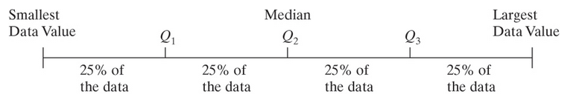
Finding Quartiles:
Step 1:

Step 2:

Step 3:

Example 14: The following represents scores of all 7 students on the first exam of a small statistics course. Find the quartiles of the exam scores:
76 | 80 | 84 | 86 | 90 | 92 | 94

Including the 8th student, find the quartiles of the exam scores:
32 | 76 | 80 | 84 | 86 | 90 | 92 | 94

Example 15: The following data represents the travel times (in minutes) to work for all seven employees of a start-up web development company. Find the quartiles.
5, 18, 23, 23, 26, 36, 43, 70

The quartiles can lead to another measure of spread: the interquartile range.
- The interquartile range, IQR, is

Example 16: For both datasets of exam scores, find the IQR.
76 | 80 | 84 | 86 | 90 | 92 | 94

Including the 8th student, find the quartiles of the exam scores:
32 | 76 | 80 | 84 | 86 | 90 | 92 | 94

Example 17: The following data represents the travel times (in minutes) to work for all seven employees of a start-up web development company. Find the IQR.
5, 18, 23, 23, 26, 36, 43, 70

- When should we use the IQR vs. the standard deviation?

Shape of Distribution | Measure of Central Tendency | Measure of Dispersion
Symmetric | Mean | Standard deviation
Skewed left or skewed right | Median | Interquartile range

Outliers
Extreme observations are referred to as outliers. Outliers can occur by chance, because of error in the measurement of a variable, during data entry, or from errors in sampling.

While determining outliers can be subjective, we do have a formal rule to determine outliers using quartiles:

Steps for checking outliers:
Step 1:

Step 2:

Step 3:

Step 4:

Example 18: For both datasets of exam scores, determine if there are any outliers.
76 | 80 | 84 | 86 | 90 | 92 | 94

Including the 8th student, find if there are any outliers.
32 | 76 | 80 | 84 | 86 | 90 | 92 | 94

3.5 The Five-Number Summary and Boxplots
- A common summary to give people about a dataset to give fast, quick information about a dataset is a five-number summary.
Definition: The five-number summary of a set of data consists of

Example 19: Refer to the exam example. Including the 8th student, find the five number summary.
32 | 76 | 80 | 84 | 86 | 90 | 92 | 94

We can use the five number summary and outliers to draw boxplots.
Step 1:

Step 2:

Step 3:

Step 4:

Step 5:

Example 20: The City of Chicago requires all ride-sharing companies to report a variety of variables on each ride including distance (in miles), fare (in dollars), and whether or not the ride was shared. The data in table below represent the distance of a ride for a random sample of 50 rides in Chicago.
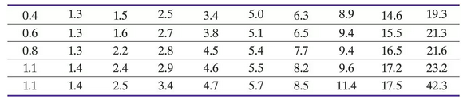

The five number summary was calculated as 0.4, 2.2, 4.85, 9.4, 42.3. Draw a boxplot of the data.

Example 21: Ride-shares come with two options: share a ride or do not share a ride. When you share a ride, you are placed in a car with a group of up to 6 people.
- Find the five-number summary from the boxplots below.
- Is there a difference in the length of a ride depending on whether the rider shares a ride with others? Explain.

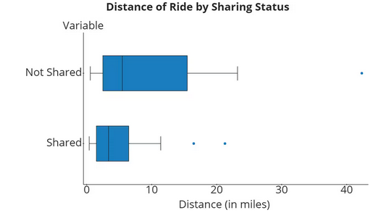

Using a Boxplot to Describe the Shape of a Distribution
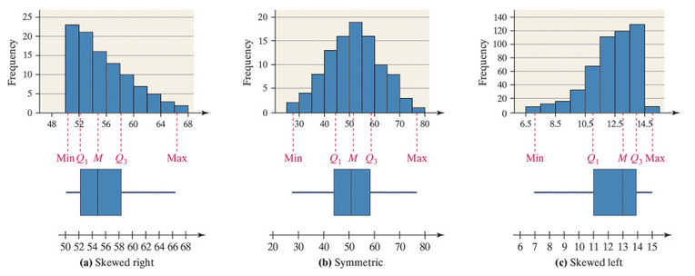

Example 22: Refer to the ride share example. Describe the shape of the distributions below.


